**DATA SET UP FOR TESTING IN SEATTLE SANDBOX:**

TEACHER 14 has data as follows:

Two observations that already existed, each with info for pre-conf, session and post-conf, including claim statement and evidence. Second observation includes claim statement for SG. Teacher has loaded two artifacts – one attached to an observation and one not. Evaluator has loaded an artifact. I left some dates blank on the second observation. I titled the second one but not the first one. Evaluator put in a score for SG.3.1 but left others blank and chose the over-ride to skip SG. Then I made a 3rd evaluation so it would be fresh after all updates were in place. There isn’t much info in that one.

8A1.T

REGARDING NEW WORKFLOW DESIGN: CHANGE THE GREY?

I suggest we use the gray a little differently. I’m finding it hard visually to know what the gray indicates, though we meant it to mean the phase was complete, it looks more like it means that the functionality is disabled and it’s hard to read.

I suggest, instead, we leave the panels white and not use the gray at all. The fact that the buttons move along to each new phase can show the user where they are in the process. If possible, we could makea dark outline of the box for the phase that is active so it stands out. If that’s tricky, then let’s see how it is when it just remains white. As for a report that has been submitted, that box will have the submit date and time which should make it obvious that it has been submitted.

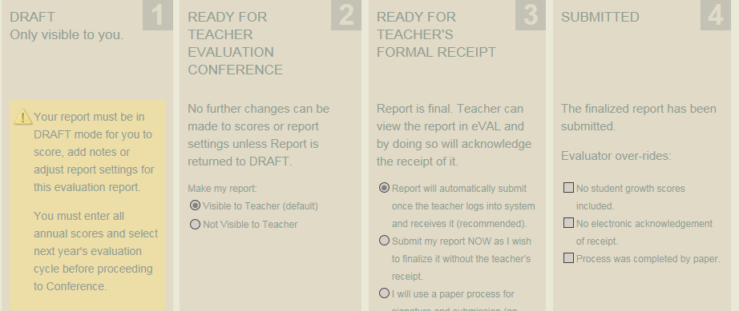

8A1.T CONT: ATTEMPTING TO SUBMIT - ERROR.

When I chose “Submit now…” using Chrome, the screen got weird and did not re-paint. When I used Firefox, I got:

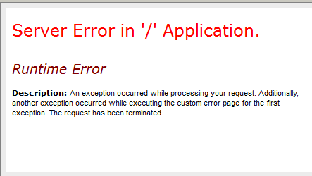

Chrome: (just FYI for you – we’re not using it)

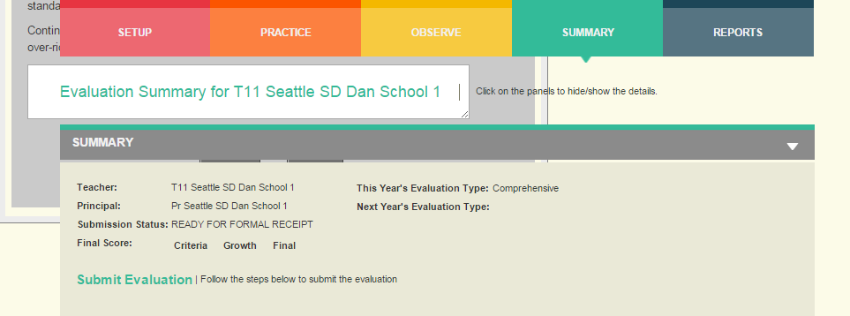

8A1.T CONT: AFTER REPORT HAS BEEN SUBMITTED:

We need the date/time to show up on Panel 4 (See slide 21 of powerpoint)

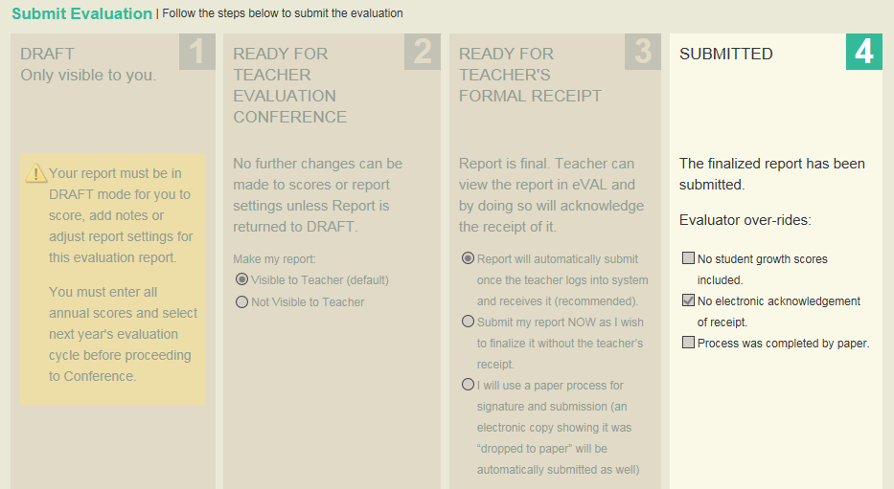

8A.2: OVER-RIDE FOR STUDENT GROWTH

If SG over-ride is selected, then final report still shows incomplete for SG

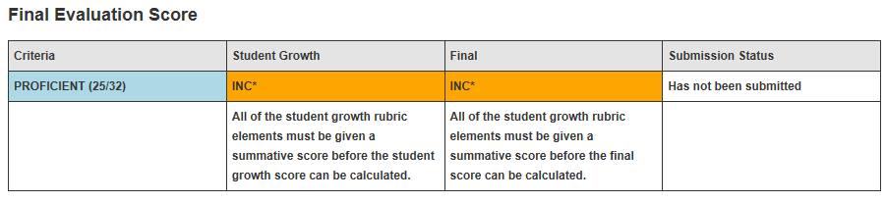

8A.2: OVER-RIDE FOR STUDENT GROWTH

Need to ignore any SG scores if over-ride is selected

If the user has entered some, but not all, SG scores, then they get the “Do you intend to over-ride” prompt as currently designed. If at this point they say yes, they want to skip SG scores, then any SG scores that the user entered will NOT be considered in the overall scoring, but they can still appear on the report individually.

Will that work? Let me know your thoughts.

REQ 8 A.6 – UNSUBMITTING A SUBMITTED REPORT

There isn’t anything that tells the evaluator that only a DA can unsubmit at this point. We could do the following: When the report is in the 4th panel (it has been submitted), then the button still exists that used to say “Return to draft”, but now it simply says “Submitted.” If the user clicks on it, they get a pop-up box as follows: “This report has been submitted. It can only be unsubmitted by a District Administrator.”

REQ 8A.7 – TEACHER ACKNOWLDGES REPORT AND IT AUTO-SUBMITS

Clicking on the PDF has error:

Firefox:



Chrome (we won’t be using Chrome, I was using it out of laziness, so this is just FYI)



Instead of clicking on PDF, should we just have control button that they click, which brings up acknowldgement message, and then the report prints to screen with choice of printing to PDF?

REQ 8A.12 PLUS MISC:

REGARDING REPORT SETTINGS AND OPENING THE PDF FILE –

I thought we had a requirement to leave this panel always open, so the user didn’t have to “find” it. But maybe I dreamt that… At any rate, is there any chance you can program it so that this panel is ALWAYS open since it has the report settings and the actual PDF file, and it’s not that intuitive that the user must click the little down triangle to find report settings, since the heading on the panel doesn’t give any indication of what’s inside…. Or, the screen defaults to it open but the user can close it for that session if they want to? Or, there’s a heading that is always visible to the user called “Report Settings”? The way the heading “Final Report” is colored and how it sits above the State Criteria, it looks like it’s just a heading for the State Criteria, it doesn’t really look like it, by itself, is a container for the report settings and the user should open it up to see what is inside.

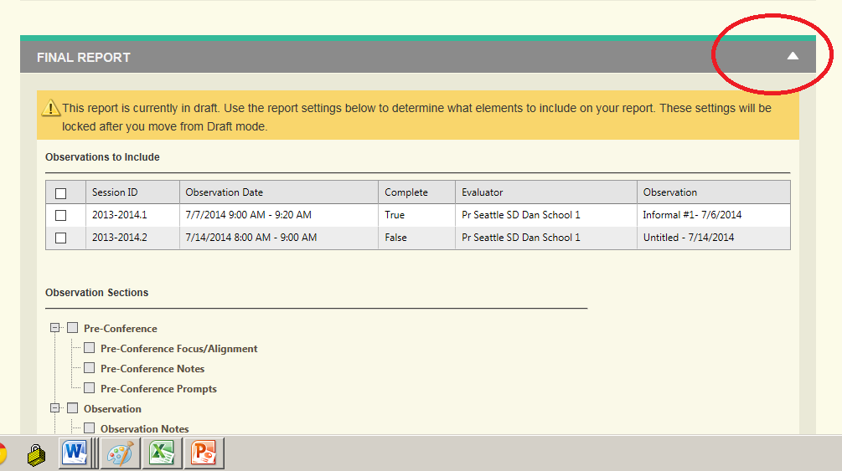

8A.16T

THE EVALUATOR’S NAVIGATION DASHBOARD

Some of the records have “Received” as the status, and I think that’s just from old records. If that’s so, then fine. But if you need a list of what to display in the Status column for each status, here is is:

* If status = Draft, then “Draft”
* If status = Ready for teacher conf, then “Ready for Conference”
* If status = Ready for teacher acknowldgement, then “Ready for formal receipt”
* [Then, after the teacher has “received” it, it goes right to submitted. There is no “Received” status]
* If status = Submitted then, “Submitted”

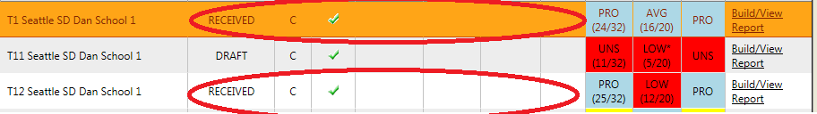

(It may be working fine and the “Received” are just from old records…)

8A.18: REGARDING BLURB THAT DISPLAYS IN PRINT SETTINGS –

Can we add one more scenario, for when report has been submitted, the text in yellow should change to “This report has been submitted. Report settings are locked and cannot be changed.”

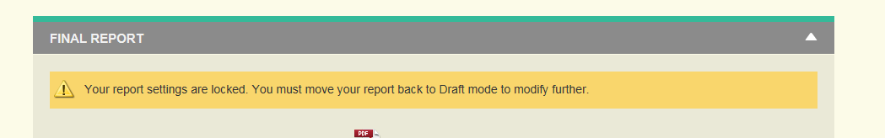

MISC: You asked for heading content on summary panel -- do you mean with which we can replace the following:

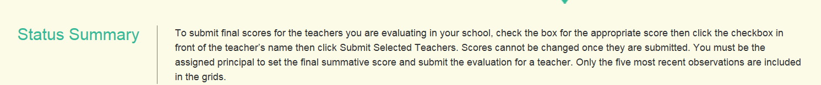

If so, then:

“Use this screen to see the status of all Summative Evaluation Reports for teachers assigned to you or at your school. Click on Build/View Report to prepare or view a teacher’s Summative Evaluation Report.”